# Flappy-Bird-esque iOS Game

Austin Carr

For my project, I will be designing a Flappy Bird type game using the game development environment, Unity. Last year, Flappy Bird at one point had reached the “Most downloaded free app” milestone on the app store, earning about $50,000 a day. That said, its no wonder why app game development has been an increasingly popular field. For my project

Primary Goals*(these must all be done for full credit)* for our project are:

* Learn Unity
* Create the Flappy Bird and Flappy Bird World
* Allow Users to play “Easy” level
* Allow Users to replay
* Allow Users to return to main menu
* Persist between plays

Pipedream Goals *(primary goals need to be sufficient for it to be a good project, these won’t be graded negatively, they may count as extra credit)*:

* Support multiple levels: “Easy”, “Medium”, “Hard”
* Integrate Facebook and Twitter
* Integrate leaderboards

Layout:

There will be three views with controllers, the Main Menu view, Play View, and Game Over view.

Main Menu View:

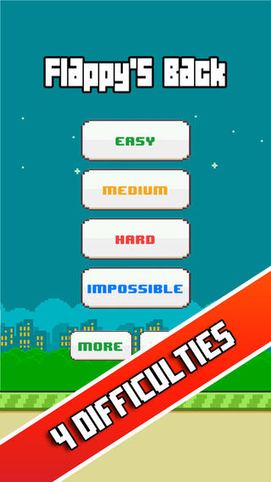

Play View:

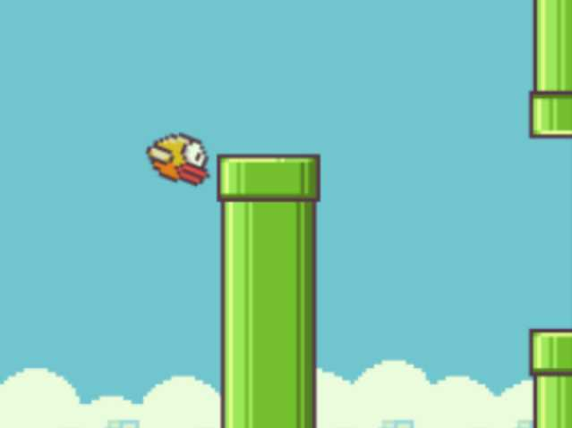

Game Over View:

